Basic Linux Commands

10: hostnamectl:

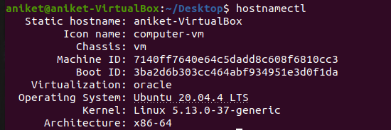

11: cal

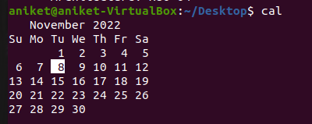

12: rm



13: vi aniket.txt

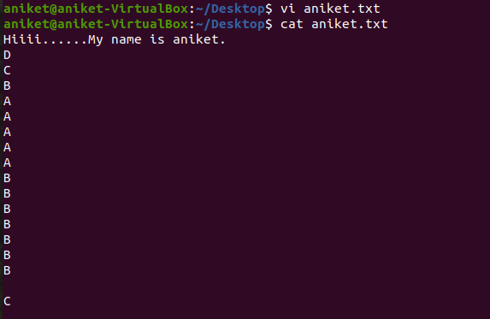

14: cp

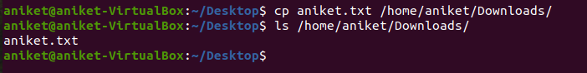

15: mv

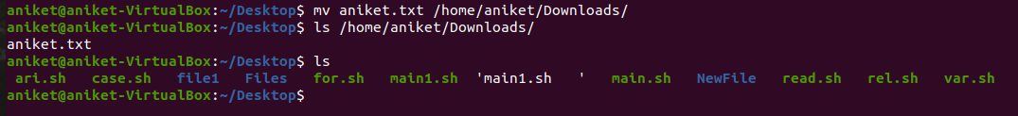

16: sudo su

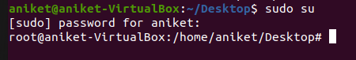

17: clear



18: ln

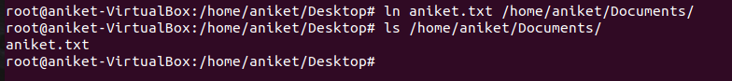

19: echo



20: df

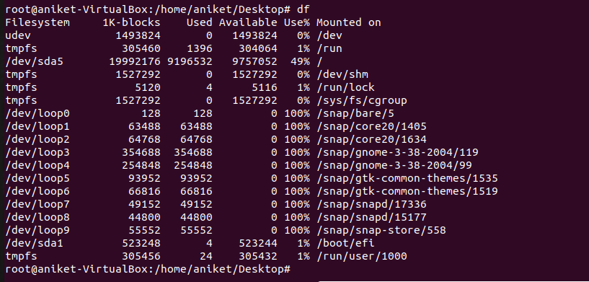

21: top

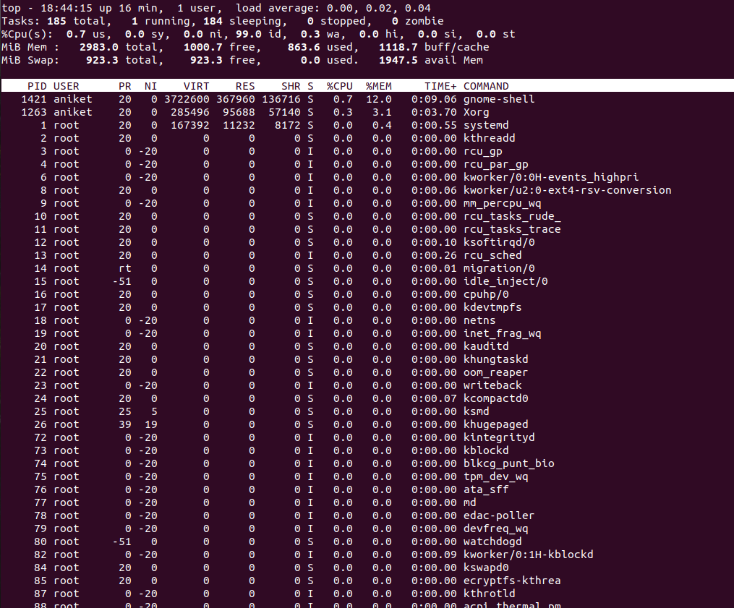

22: uname -a



23: tar -cvf



24: tar -xvf

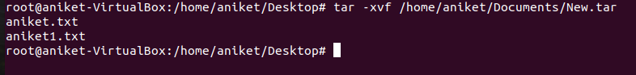

25: zip

